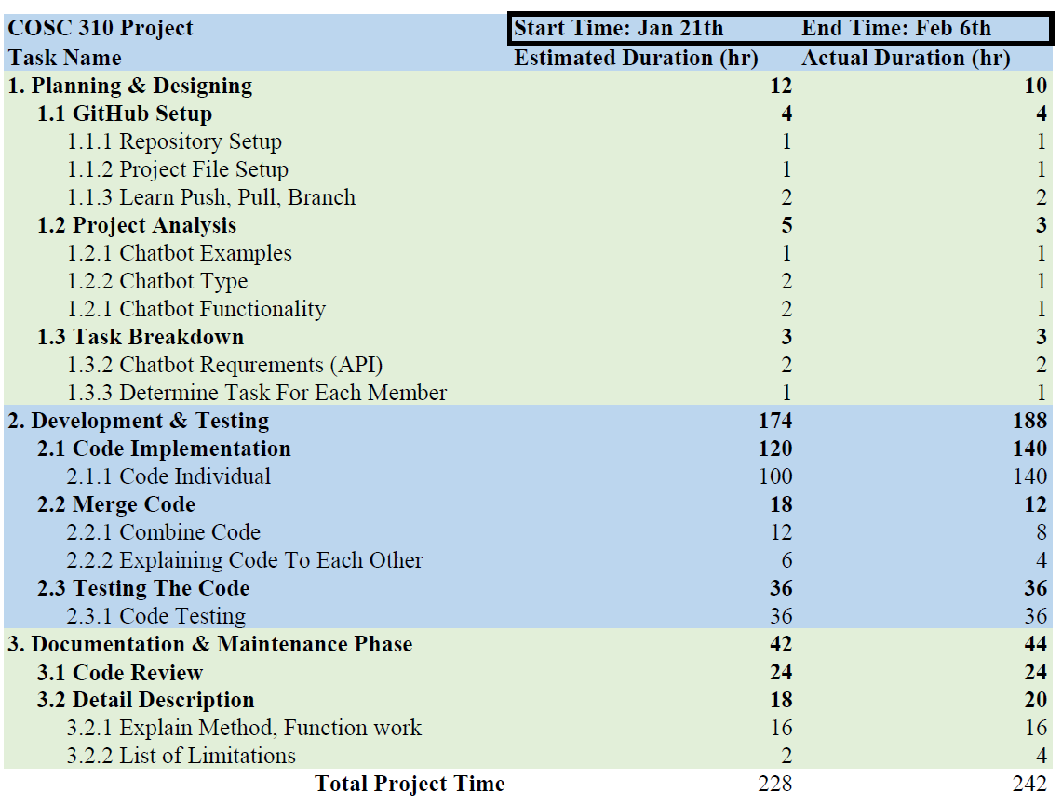

In Planning and Designing phase, we estimate 12 hours of working time. However we spent 10 hours on this phase, which is pretty close to our estimated time.

In phase 2, Development and Testing, our WBS chart shows that we spent most of the time in this phase, and we end up have to spend more time on code implementation. Our actual time on merging the code is less than the estimate time is because we utilized the pull and push function in GitHub.

In Documentation and Maintenance phase, our actual time is very close to the estimated time. And we spend a little more time on the documenting the methods, and functions.